Following are the some rules for the xpath:



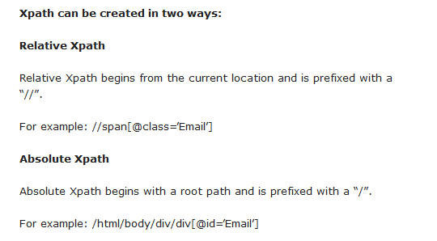

Xpath Axes:

1. Parent Node:

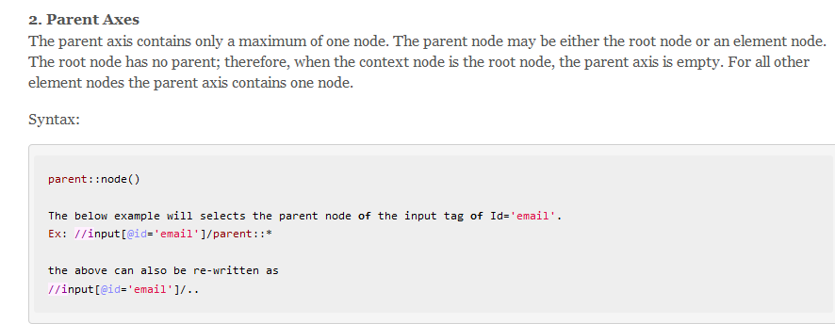

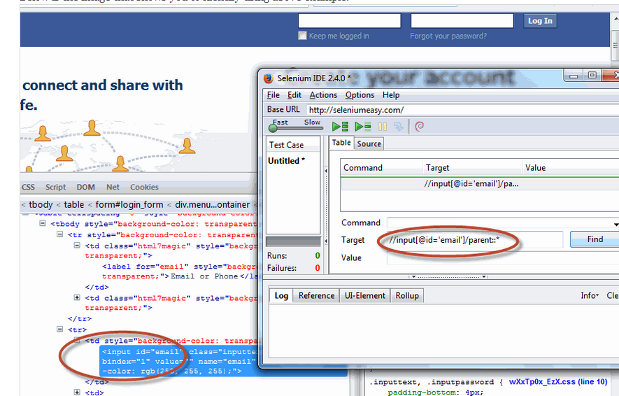

1. Following axes:

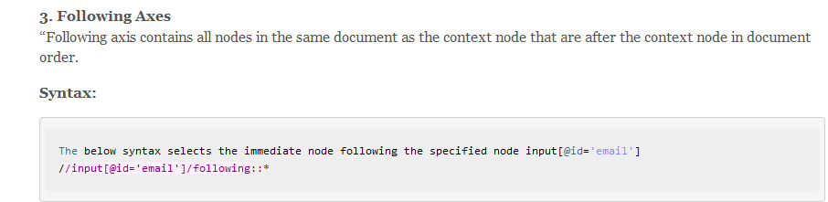

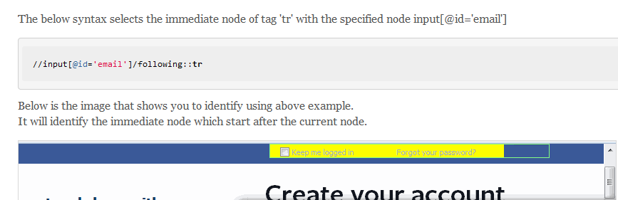

1. Following-sibling axes:

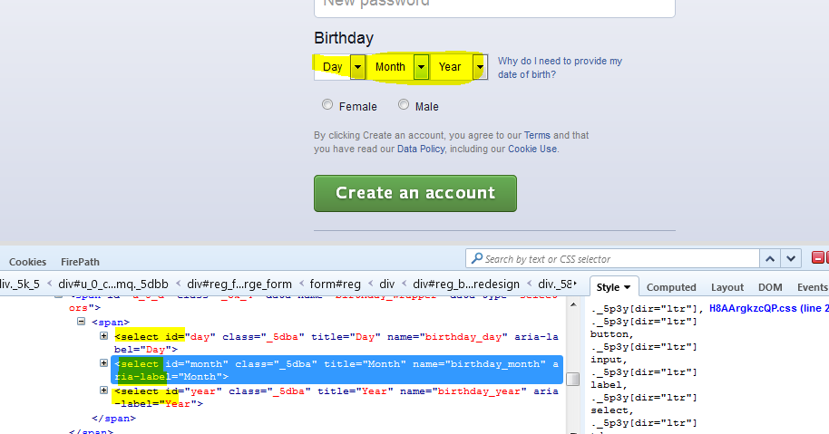

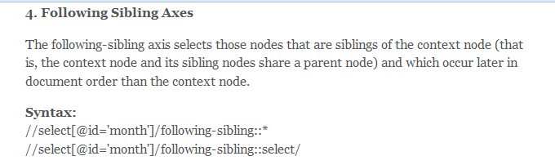

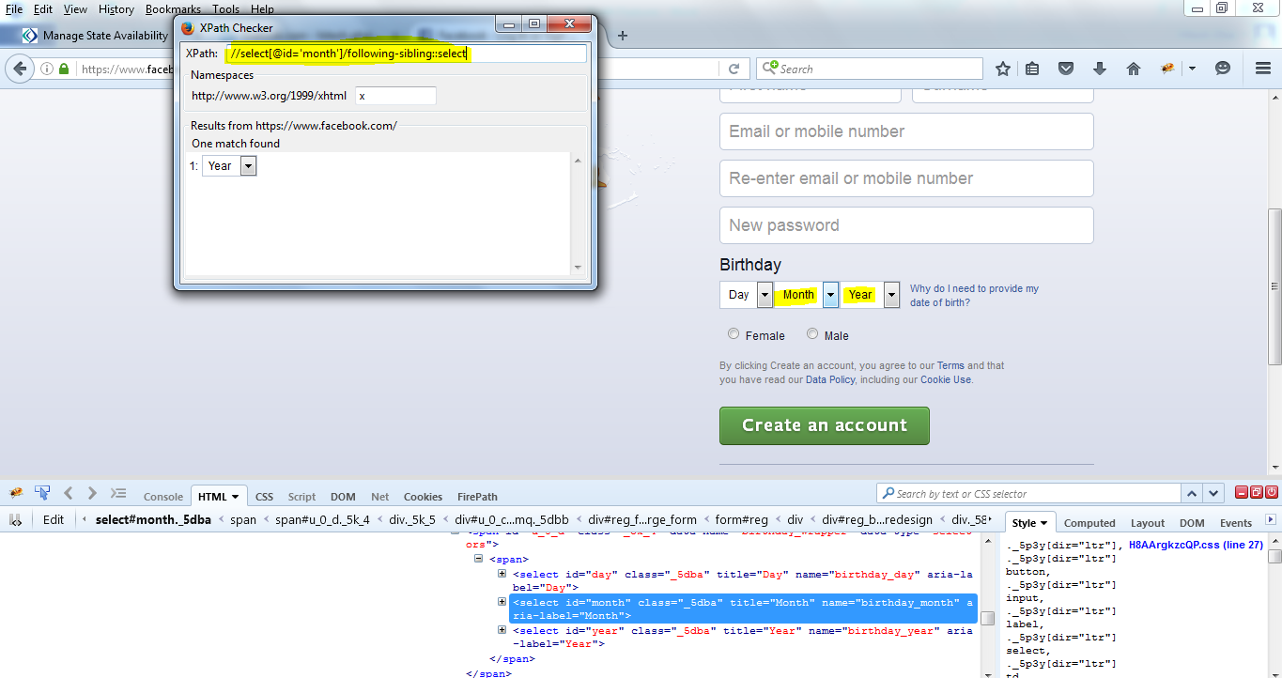

In the above example, the following sibling of an element “//select [@id='month']” is “Year” drop down. So in order to get “Year” drop down web element, the above or following x path can be used.

//select[@id='month']/following-sibling::select

Same goes with following-preceding. It will select and get “Day” drop down. Below is an example:

**//select[@id='day']/preceding-sibling::select/**